Page set up

# Purpose

The following illustrates how to set up a single Blackboard content area page to use the Content Interface.

**Looking beyond a single page?**

The [*Authoring set up* page](https://djplaner.github.io/Content-Interface-Tweak/using/authoringSetup/) provides advice on how to set up authoring for an entire course.

Setting up a single page to use the Content Interface requires that you add at least two of the following three items to the page:

1. Content Interface (required);  
   The content of your Word document will be displayed within this item.
2. Content Management Instructions (required);  
   The code that implements the Content Interface. This is also where instructions on how to use the Content Interface will appear. This item is only visible when [*Edit Mode*](https://elearn.southampton.ac.uk/blackboard/quickedit/) is on (i.e. typically not visible to students).
3. Content Document (optional).  
   A web link that points to an appropriately shared link to the Word document for this page

The *Content Document* link is only useful for files shared via Griffith University’s OneDrive/SharePoint drives)

## Assumed Blackboard knowledge

The following assumes that you are reasonably familiar with adding content to Blackboard Learn.

In particular, that you are aware the in Blackboard a [Content Area](https://help.blackboard.com/Learn/Instructor/Course_Content/Create_Content/Create_Containers_for_Content) (see Figure 1) is one of the main ways to group together content.

That a content area can include a number of [Content Items](https://utlv.screenstepslive.com/s/faculty/m/BlackboardLearn/l/185559-creating-a-content-item) and other [content types](https://help.blackboard.com/Learn/Instructor/Course_Content/Create_Content/Create_Course_Materials/Types_of_Course_Content).

## Assumed starting point

It is also assumed that you have created or identified a Content Area into which you wish to place the Content Interface. i.e. this is where you want your content to appear. For example, Figure 1 shows an empty Content Area that will be used throughout this process.

**It doesn’t have to be empty**

The Content Interface can be added to a page that already contains other items. Your Content Area doesn’t need to be empty.

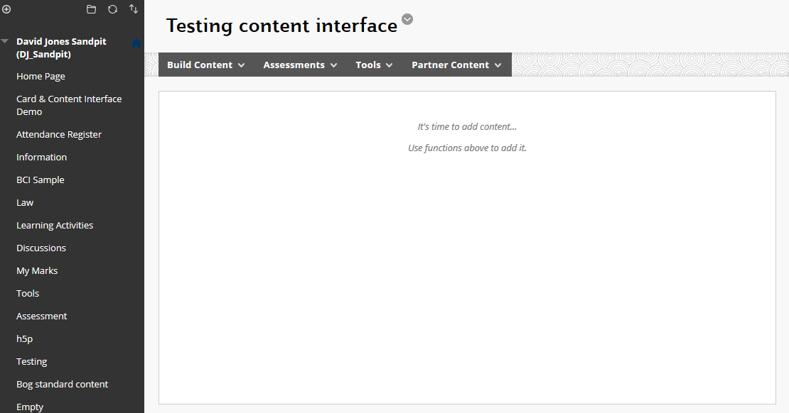

Figure 1 - Empty content area in Blackboard

# 1. Add the “Content Interface” content item

The **Content Interface** item is where the content from your Word document will be placed and where students will see it.

1. [Add a Content Item](https://help.blackboard.com/Learn/Instructor/Course_Content/Create_Content/Create_Course_Materials/Create_Content_Items_or_Documents#create-a-content-item_OTP-0) to your Blackboard page.
2. Give it the name **Content Interface** and leave it empty (see the screenshot below).

**The name is important, make sure it’s right**

The name – Content Interface – is used by the code to look for content it should work on. If it can’t find the name, then it won’t be able to do its work.

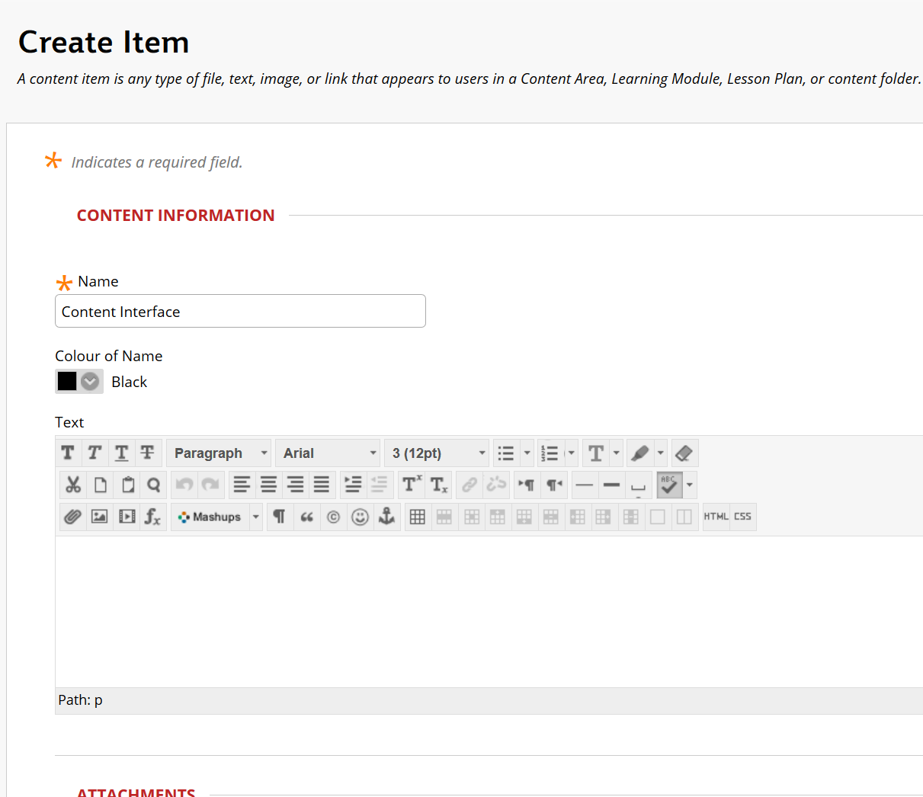

Figure - Creating Content Interface item

# 2. Add the “Content Management Instructions” item

The **Content Management Instructions** item serves two purposes:

1. It contains the code that implements the Content Interface.
2. It will display the instructions and support material to help you use the Content Interface (but only when [Edit Mode](https://elearn.southampton.ac.uk/blackboard/quickedit/) is on).

To add this item

1. [Add a new content item](https://help.blackboard.com/Learn/Instructor/Course_Content/Create_Content/Create_Course_Materials/Create_Content_Items_or_Documents#create-a-content-item_OTP-0) to your Blackboard page.
2. Give it any name you like, but **Content Management Instructions** is recommended.
3. Copy the Content Interface code from [this page](https://raw.githubusercontent.com/djplaner/Content-Interface-Tweak/master/tweak.html).
4. Open up [the HTML Code view](https://sites.reading.ac.uk/tel-support/2019/08/30/blackboard-view-html-code/) for your content item.  
   The **HTML** button is circled in red in Figure 3
5. Paste the Content Interface code into the HTML Code view.  
   As shown in Figure 3.
6. Update and submit your changes.

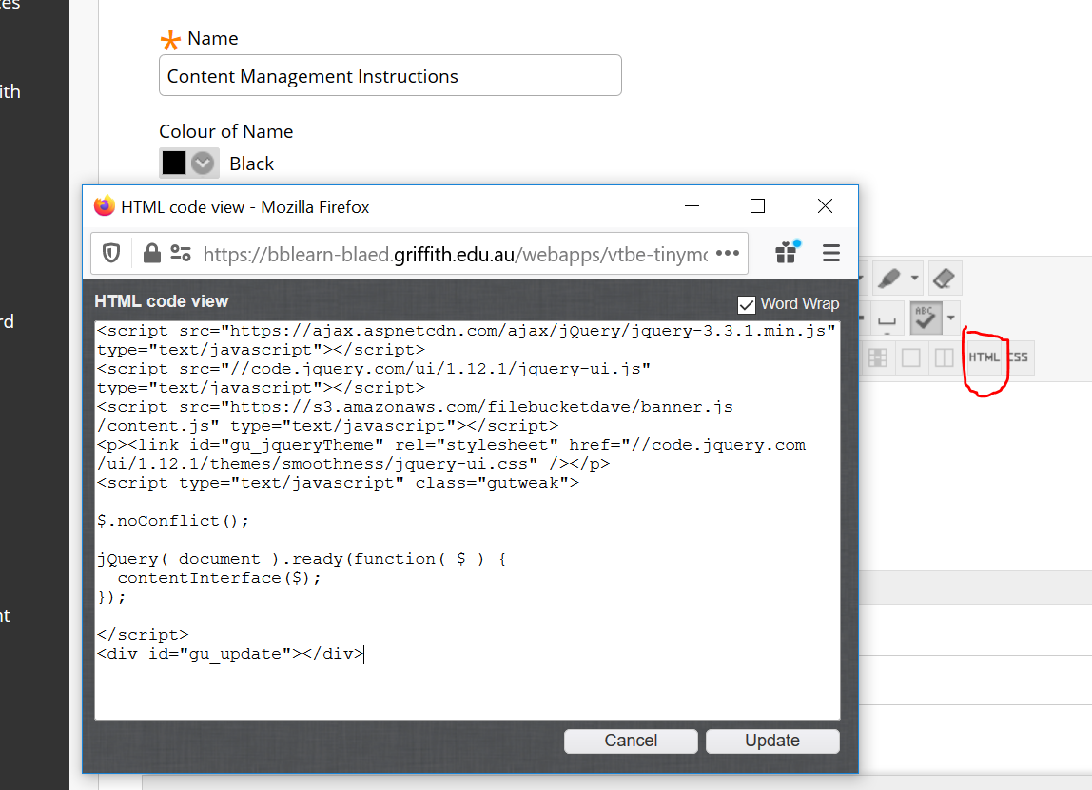

Figure - Pasting the Content Interface code

# What you will see – after two steps

Correctly adding these two items should result in you seeing something like Figure 4 showing the two items you have added.

The main point to check is that the **Content Management Instructions** item should be showing a collection of instructions explaining how to use the Content Interface. This shows that the Content Interface code is operational.

At this stage the **Content Interface** item remains empty, waiting for the content from the Word document to be placed into it. The instructions will explain (see the *How to update the content* card in Figure 4) how to do this using the default manual process. To automate this process more, complete the following step.

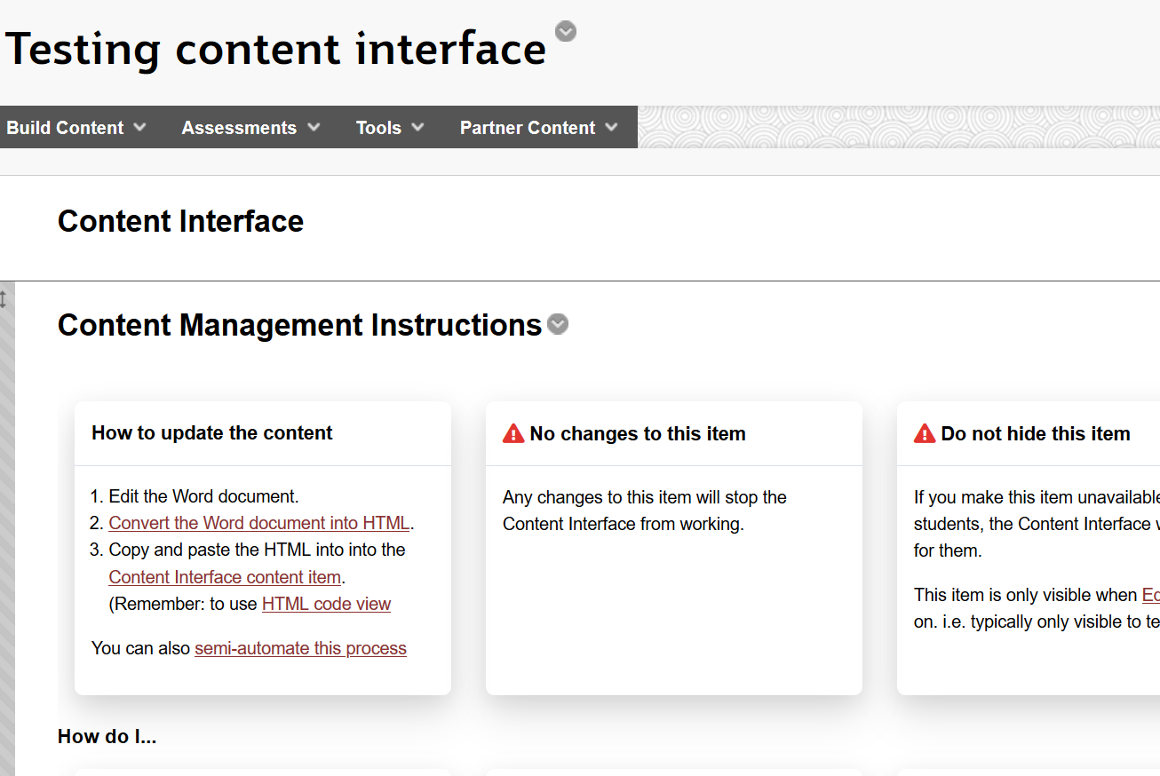

Figure - Content Interface set up

# 3. Add the **Content Document** item

Adding the **Content Document** item helps to further automate the process of updating content in Blackboard. This is achieved by providing appropriately shared link to the Word document where you are creating and editing the content.

This will only work with Word documents that are shared via Griffith University OneDrive/SharePoint services.

Support for other file sharing services or other institutions would require additional code to be written to work.

## Create a OneDrive/SharePoint shared link to the Word document

The first step is to place your Word document onto a OneDrive or SharePoint shared drive. This then enables you to create a shared link. i.e. a link that enables different collections of people to access your Word document via the Web. The aim here is to provide such a link to the Content Interface code so that it can help semi-automate the update process.

1. Hit the **Share** button.  
   This starts the process. A **Share** button can be found in a couple of places, including: when editing the Word document (Figure 5) or right clicking on the file in an Explorer or Finder window (Figure 6)

|  |  |
| --- | --- |
| Figure 5 - Share button - Word | Figure 6 - Share button - Explorer window |

1. Change the link settings.  
   When you start the share process you will see something Figure 7. Initially, the settings for the link you will create are set so that you have to specify the email addresses of people to whom you wish to grant access. To change the settings, click on the box containing **People you specify can edit**.

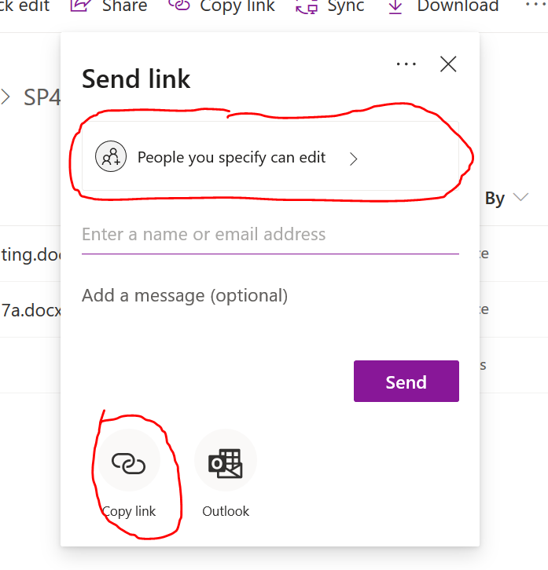

Figure 7 - Initial Share dialogue box

1. Change link settings to **People with existing access**  
   Initially you see something like Figure 8. Select the **People with existing access** option (Figure 9) and hit the **Apply** button.

|  |  |
| --- | --- |
| Figure 8 - Initial link settings | Figure 9 - Recommended link settings |

1. Copy the link into the clipboard.  
   You should now see something like Figure 10. Note that the link settings has changed to **People with existing access can use the link**. Hit the **Copy** button (circled in red) to copy the newly created shared web link into your clipboard.

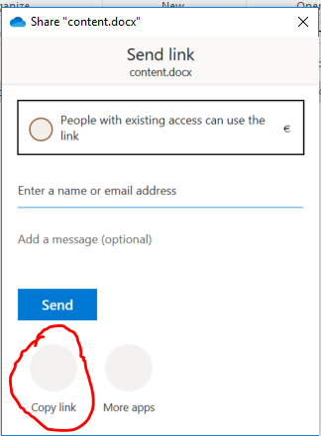

Figure 10 - Copy link

## Add a Web link called “Content Document” to the Blackboard page

Now that you have created your shared web link to the Word document, the next step is to add it to the Blackboard page.

To do this you need to [add a Web Link item to the Blackboard page – instructions here](https://utlv.screenstepslive.com/s/faculty/m/BlackboardLearn/l/185566-creating-a-link-to-an-external-site-in-blackboard). The Web Link item you create should have the name **Content Document** and the link should be the shared link you just created to the Word document (see Figure 11).

You can test the link. Once you’ve added the link to the Blackboard page, click on it. It should take you to an online version of the Word document.

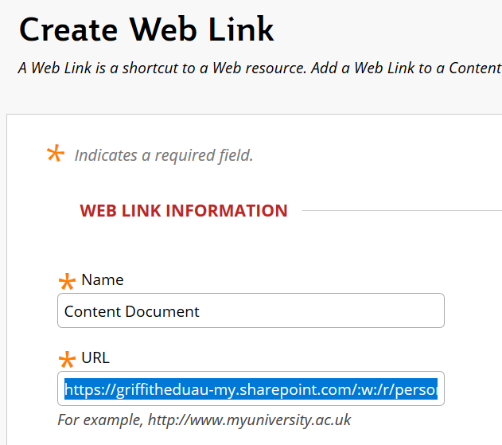

Figure 11 - Creating web link item

# What you will see – after three steps

Before completing the 3rd step and adding the **Content Document** item you should have seen something like Figure 4 on your Blackboard page. Adding the **Content Document** item will change the appearance slightly (Figure 12).

The major change will be to the instructions for *How to update the content*, including the green **Update Content Interface** button. If you press that button the semi-automated update process will start.

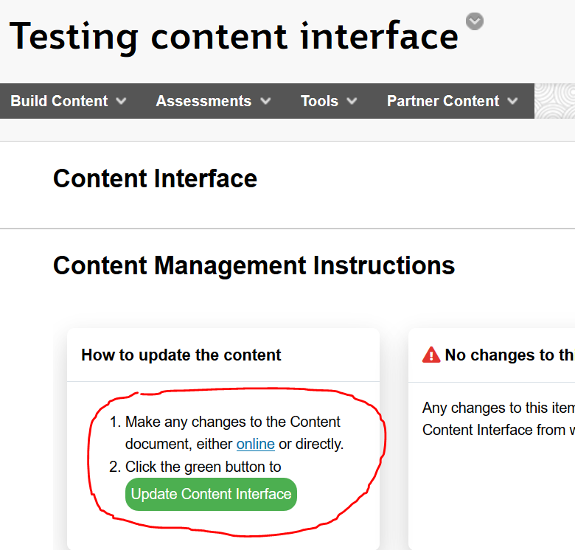

Figure 12 - Changes to the instructions after adding the "Content Document" link